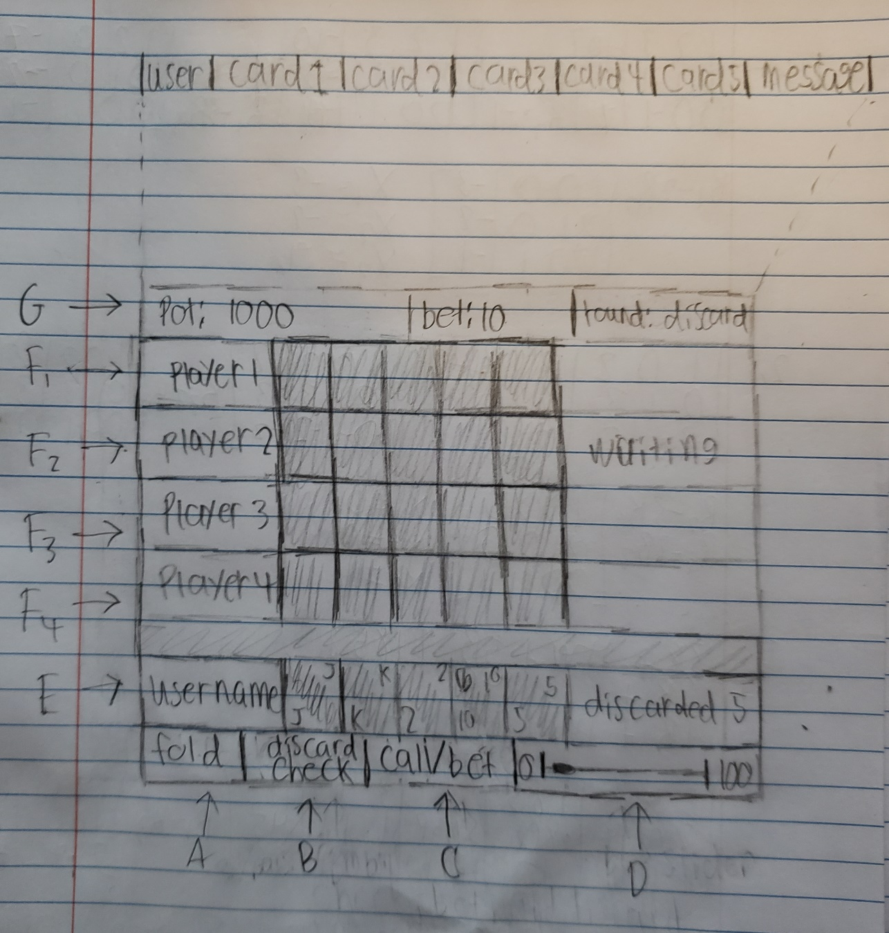

**Requirements**

1. Button – 10.00, 10.07, 10.12, 10.13, 10.14
2. Button – (Check) 10.00, 10.02, 10.03, 10.04, (Discard) 11.00, 11.01
3. Button – (Call) 10.00, 10.10, 10.11 (Bet/Raise) 10.00, 10.05, 10.06, 10.07, 10.08, 10.09
4. Slider – 10.00, 10.05, 10.06, 10.06, 10.07, 10.08, 10.09, 10.10, 10.11
5. Client cards – 3.02, 11.00, 11.01
6. Other clients – 3.02, 13.00
7. Info – 9.01, 10.00, 11.00, 12.00, 12.01, 13.00